

**Advance Web Application Development**

**Task 2**

**Use Comments and Include Tags in a single code.**

Instructor:

**Tahir Shafi**

Prepared By

**Noman Asif**

**Code**

**Comment.html file Code**

<!DOCTYPE html>

<html lang="en">

<head>

<meta charset="UTF-8">

<meta name="viewport" content="width=device-width, initial-scale=1.0">

<title>Task 2 - Comments, iframe</title>

</head>

<body>

<!-- Task 2 -->

<!-- Make a webpage Comment.html having text “I am Internal Text” with having commented text “I am Comment” that will

not display in the webpage. Make another webpage with name IIncluded.html containing the text “I am External Text” and display its contents in Comment.html webpage. -->

<!-- First Comment -->

<h1>Comment Page</h1>

<p>I am internal Page Comment</p>

<!-- External Comment -->

<iframe src="IIncluded.html" frameborder="0"></iframe>

</body>

</html>

**IIncluded.html file Code**

<!DOCTYPE html>

<html lang="en">

<head>

<meta charset="UTF-8">

<meta name="viewport" content="width=device-width, initial-scale=1.0">

<title>Task 2 - Comments, iframe</title>

</head>

<body>

<!-- Task 2 -->

<!-- Make a webpage Comment.html having text “I am Internal Text” with having commented text “I am Comment” that will

not display in the webpage. Make another webpage with name IIncluded.html containing the text “I am External Text” and display its contents in Comment.html webpage. -->

<!-- Second Comment -->

<p>I am External Comment</p>

</body>

</html>

**Result**

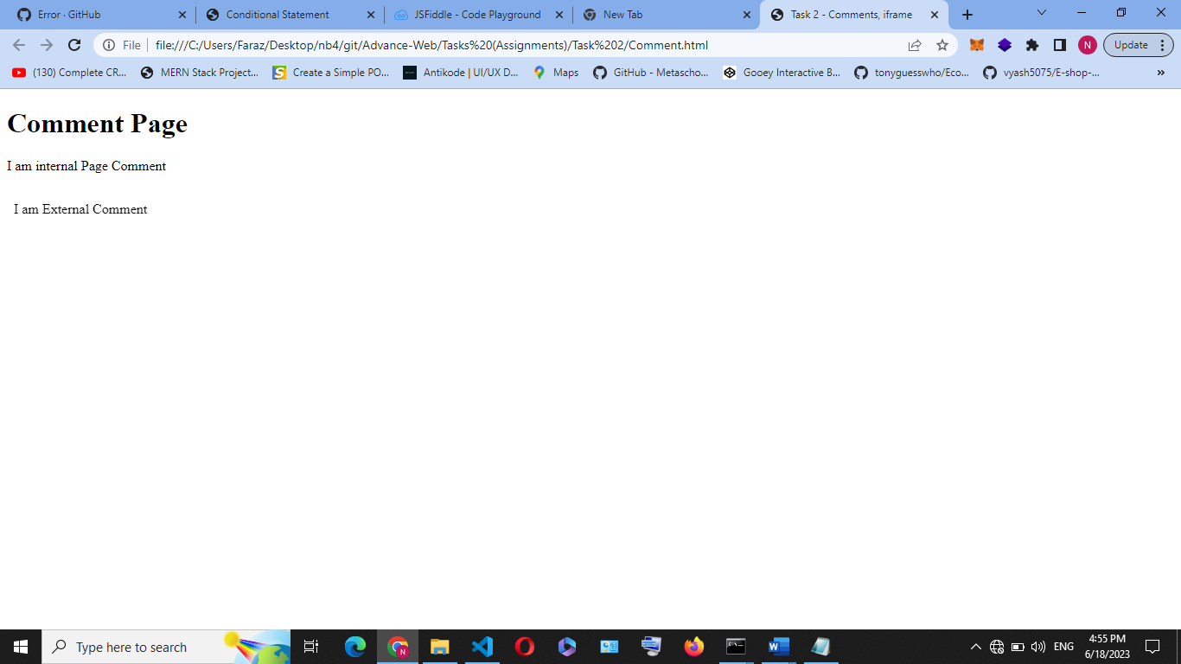s